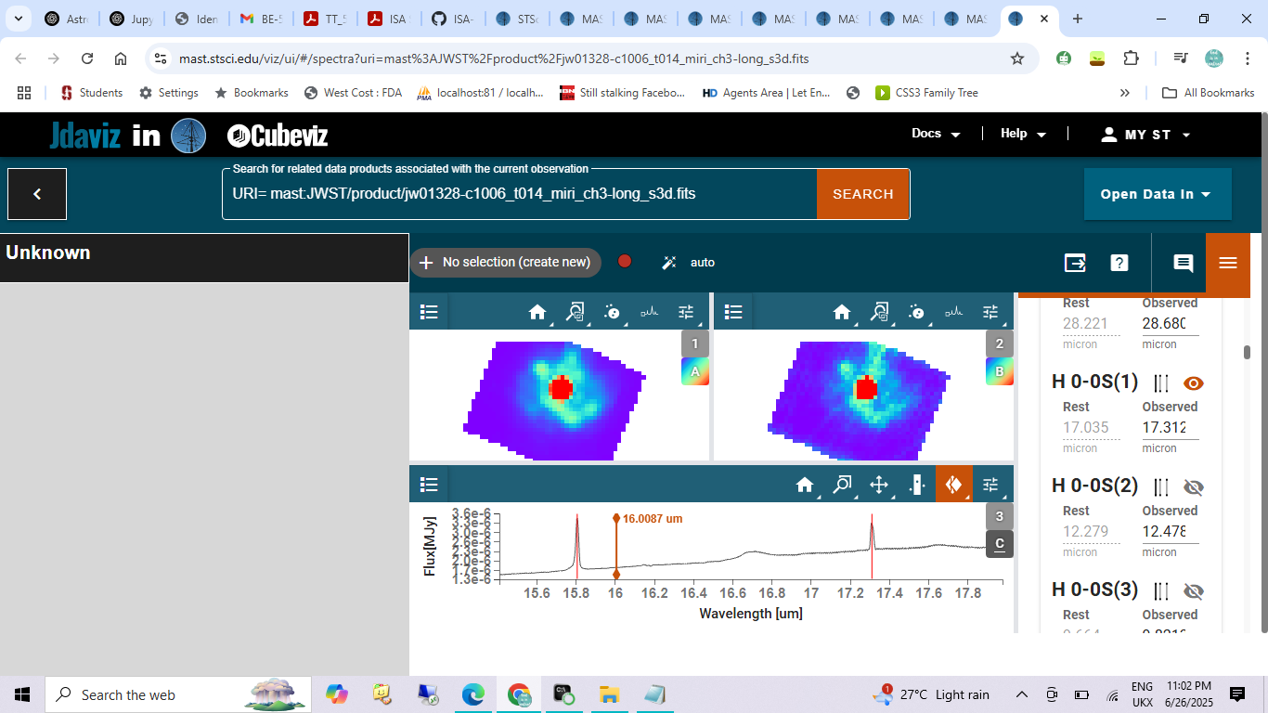
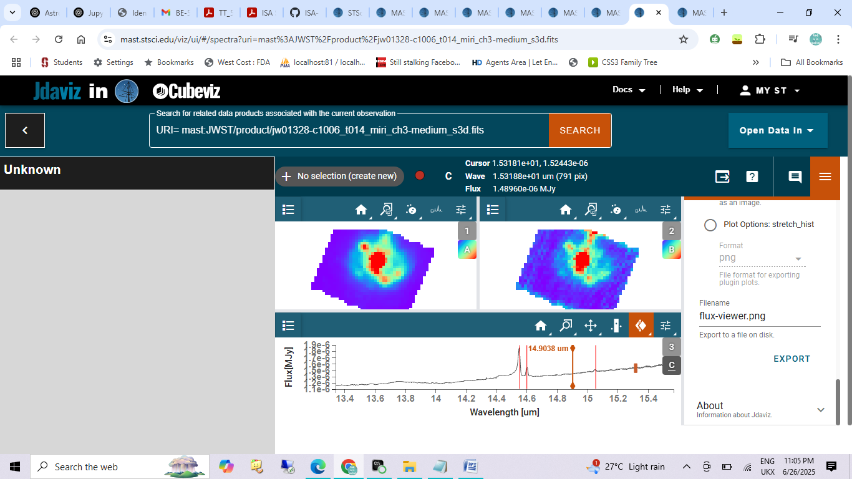
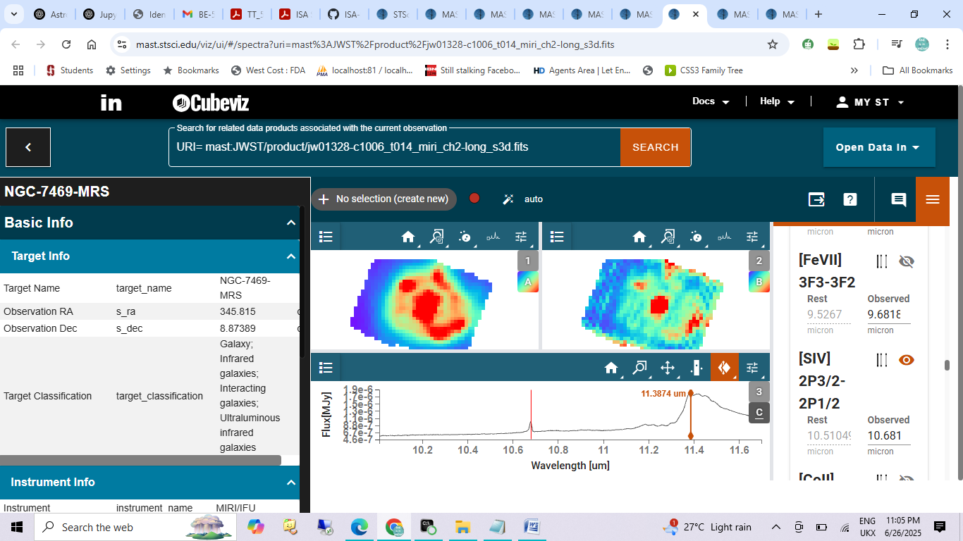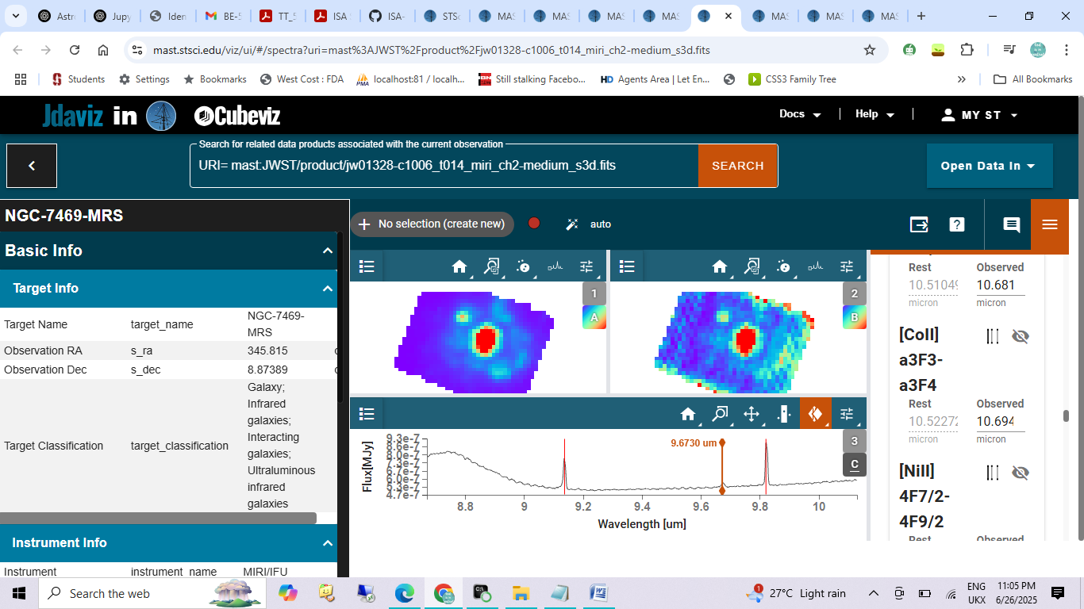

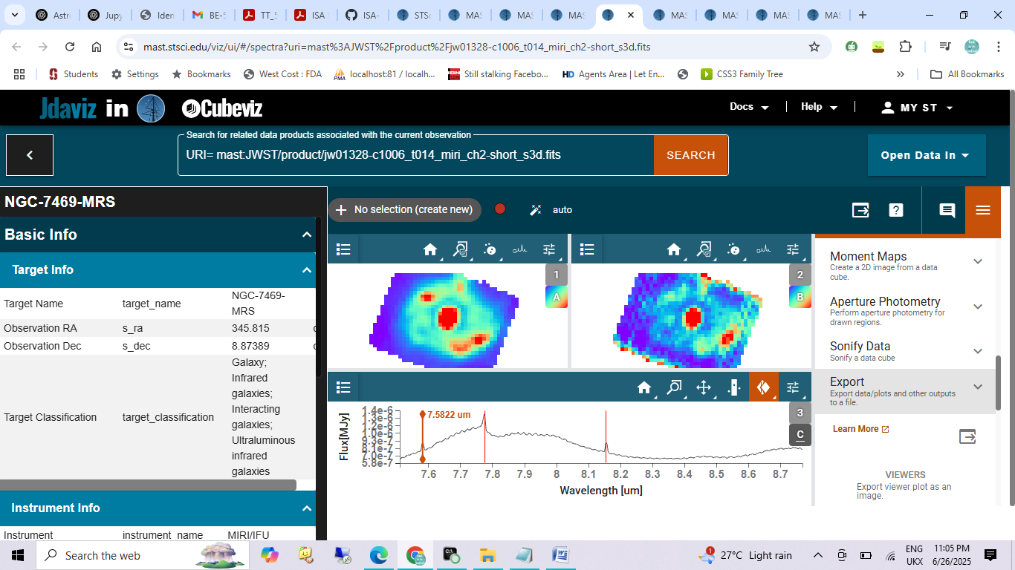
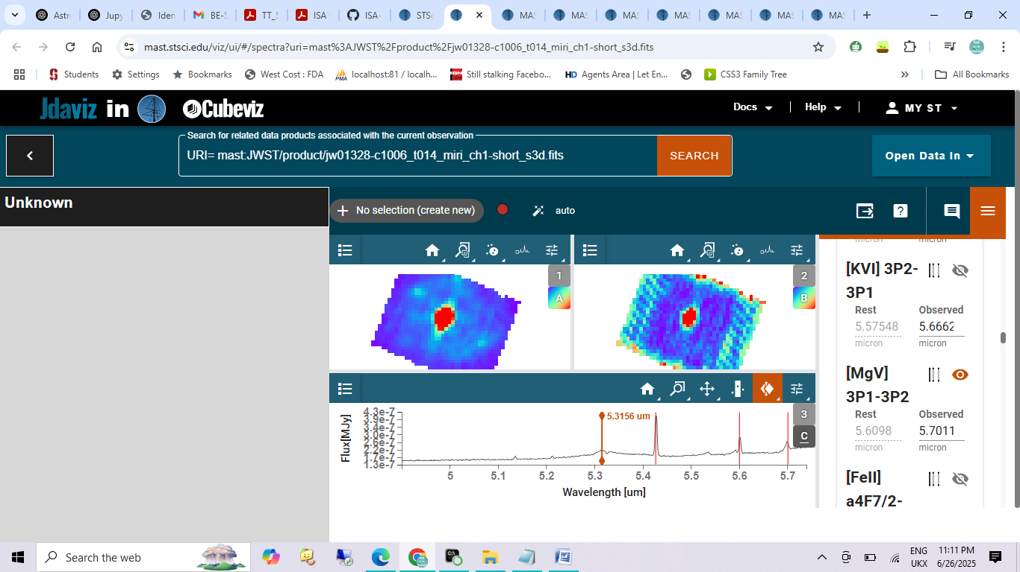
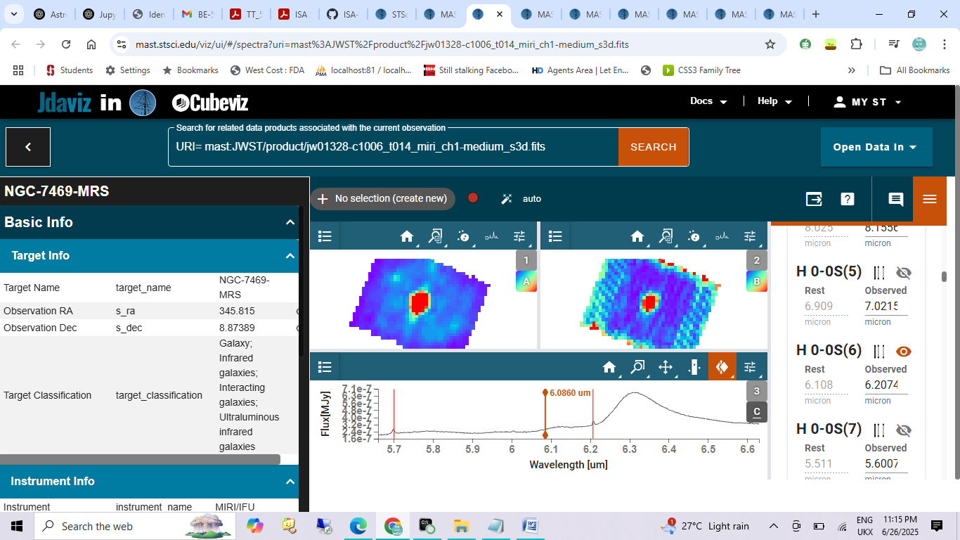
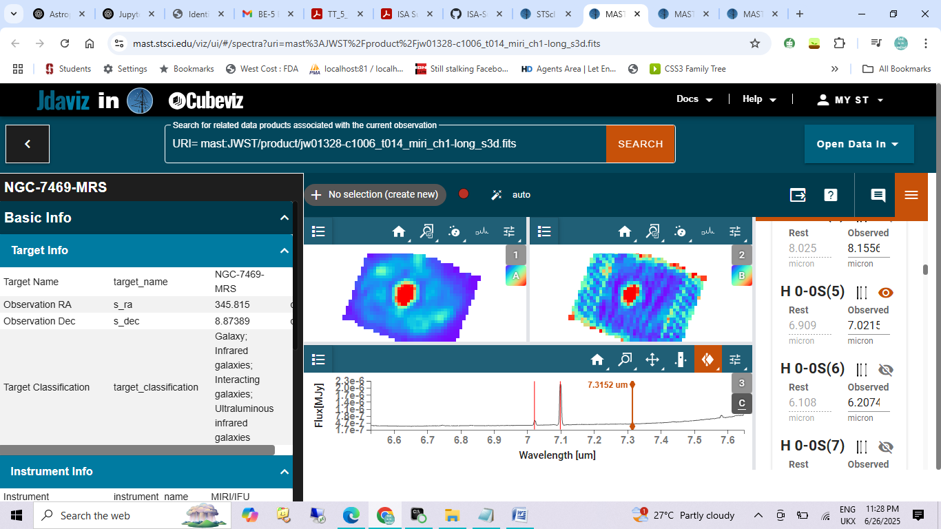
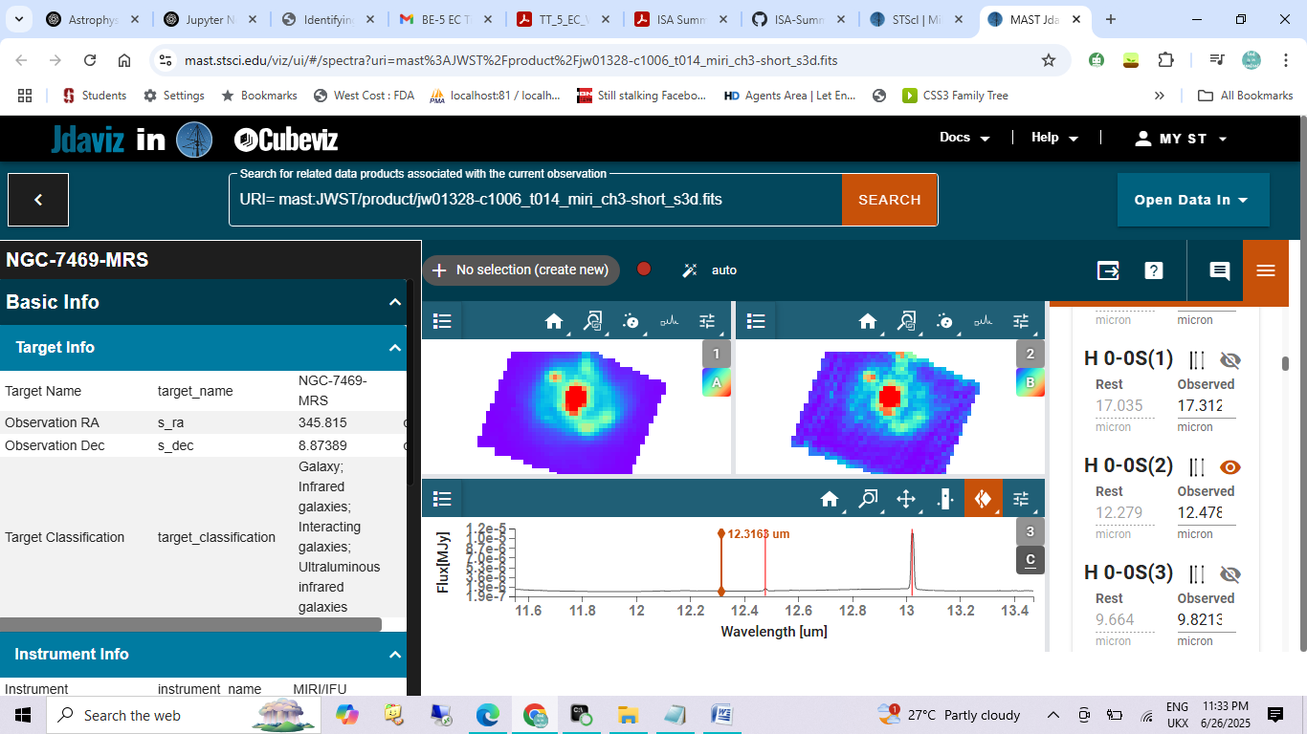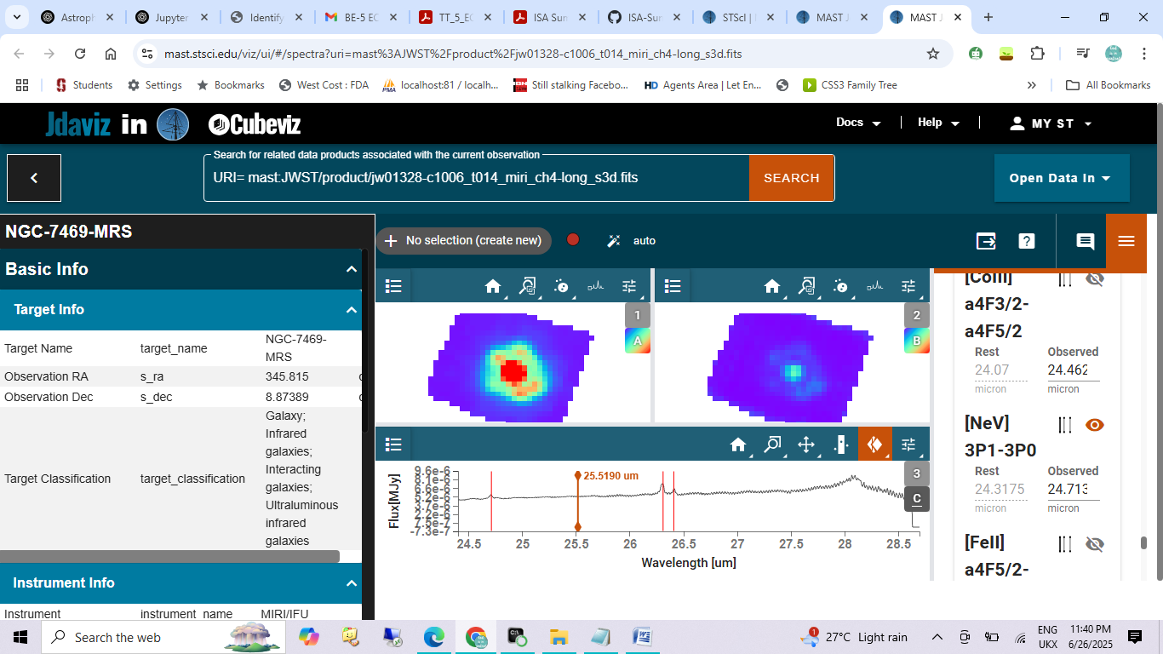
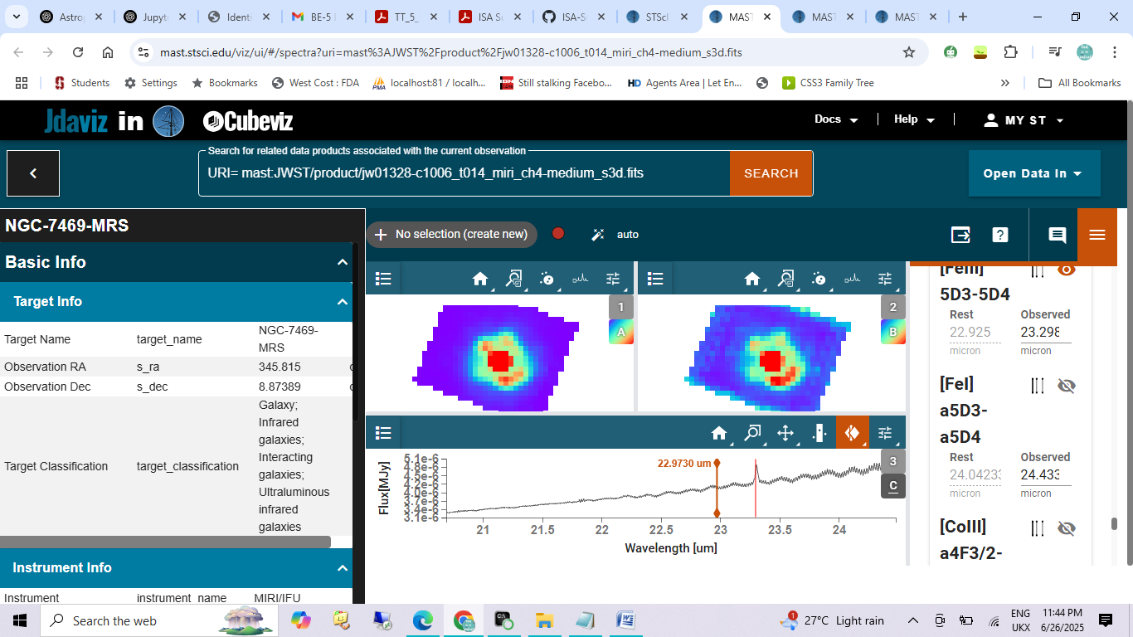
Ch1 short
Atomic- [FeIII] a4F9/2-a6D9/2-5.4271microns
H2-H0-0s(7)-5.6007 micron
Ch1 medium
Atomic-[MgV] 3P1-3P2-5.7011 micron
H2-H0-0S(6)-6.2074 micron
CH1 LONG
ATOMIC-[ArII]2P1/2-2P3/2-6.8307 micron
H2-H0-0S(5)-7.0215 micron
CH2 SHORT
Atomic- [NeVI] 2P3/2-2P1/2-7.7770 micron
H2-H0-0S(4)-8.1556 micron
CH2 MEDIUM
Atomic- [ArIII]3P1-3P2-9.1378 micron
H2-H0-0S(3)-9.8213 micron
CH2 long
Atomic- [SIV]2P3/2-2P1/2-10.681
CH3 SHORT
ATMOIC-[NeII]2P1/2-2P3/2-13.022
H2-H0-0S(2)-12.478
CH3 MEDIUM
ATOMIC-[NeV]3P2-3P1-14.554
-[ClIII]3P1-3P2-14.601
-[Nil]a3D2-a3D3-15.055
CH3 LONG
ATMOIC-[NeIII]3P1-3P2-15.808
H2-H0-0S(1)-17.312
CH4 MEDIUM
ATOMIC-[FeIII] 5D3-5D4-23.298
CH4 LONG
ATOMIC-[CoI]b4F3/2-b4F5/2-26.352
-[FeII]a6D7/2-a6D9/2-26.411
-[NeV]3P1-3P0-24.713

